**The Role of Linear Algebra in Digital Image Processing**

Final Draft

Names and IDs:

Youssef Hatem Mostafa, 211001689, Youssef Mahmoud Abdelsamea, 211001545

Nada Ahmed Othman, 202001964, Abdelrahman Yasser Hussein, 211000008

Mostafa Mohamed Eleimy, 211000048, Youssef Ashraf ElNaggar, 211001713

Submitted to:

Dr. Marwa Aref Sorour

Eng. Sief Eldeen Farag

**Table of contents**

1. **Abstract……………………………………………………………………………………...3**
2. **Introduction…………………………………………………………………………………4**

**2.1 Linear Algebras’ Role in Image Processing……………………………………………4**

**2.2 Previous Studies…………………………………………………………………………4**

**2.3 Aim of the study…………………………………………………………………………6**

1. **Methodology…………………………………………………………………………………7**
   1. **Brightness Adjustments ……………………………………………………………….7**
   2. **Rotation ………………………………………………………………………………...8**
   3. **Transpose……………………………………………………………………………….8**
   4. **Inversion ………………………………………………………………………………..8**
2. **Results…………………………………………………………………………………..........9**
   1. **Brightness Adjustments Results……………………………………………………..9**
   2. **Rotation Results ………………………………………………………….................10**
   3. **Transpose Results…………………………………………………………………...11**
   4. **Inversion Results……………………………………………………………………12**
3. **Conclusion...……………………………………………………………………………...13**
4. **Appendex…………………………………………………………………………………14**
5. **Refrence………………………………………………………………………………......15**
6. **Divded work………………………………………………………………………………16**
7. **Abstract**

Linear Algebra has a huge involvement in image processing from matrix operation that used in a variety of features in image preprocessing from playing with the density of the image, compress the image, rotate the image, invert the image, and image contrast. This study investigates the utilization of matrix operations in image processing, specifically focusing on scaler multiplication, matrix multiplication, inversion, and transposition and their effects on aspects like brightness adjustment, geometric transformations, flipping, and inverting. The research, which is based on linear algebra, uses matrices to describe pictures, with each member standing in for a pixel. The study explains how matrix operations affect pixel values for contrast, brightness, intensity adjustments, and geometric transformations, highlighting the fundamental significance of linear algebra in image processing. The results section highlights outcomes, illustrating brightness adjustments, rotations, transformations, and image reversion by comparing the image results to its original state. research's results emphasize the importance of linear algebra in image processing, by providing real life examples and contributing to a deeper understanding using python language to produce these results.

*Key words:* *Linear Algebra, Digital Image Processing, Image processing techniques, matrix operations, innovative approach, computational technology, Matrices*

1. **Introduction**

**2.1 Linear Algebras’ Role in Image Processing**

Image processing is considered a transformational discipline in the field of visual data analysis. It uses sophisticated computer tools to analyze, improve, and extract useful information from the complex web of digital pictures. Linear algebra plays a crucial role in connecting the visual complexity of digital imaging with mathematical abstraction in the vast field of image processing. Renowned for its fundamental concepts in vector spaces, matrices, and linear transformations, linear algebra has become an essential tool for deciphering the intricate patterns contained in the pixelated fabric of photographs. The mathematical foundation of image processing is essentially revealed when visual input is represented as digital matrices, each pixel taking on a numerical value, and the combination of these values captures the fine features of the image. This matrix-centric paradigm highlights the close relationship between image processing and linear algebra, where the analytical strength in decoding and transforming visual information is based on the mathematical rigor of matrices and vectors. It also offers a systematic framework for computational manipulation. There are many operations that can be performed with this matrix representation, ranging from simple improvements to complex transformations, demonstrating the flexibility and strength of linear algebra in forming the visual story that is stored in the pixels.

**2.2 Previous Studies**

The preceding papers have concentrated on the application of linear algebra in various image-processing tasks such as image filtering, contrast enhancement, transformation, and rotation. According to Ashraf et al. (2023), the primary focus of this research was on altering color through the manipulation of RGB values. By multiplying an RGB image with a color matrix, it is possible to adjust the color balance using a 3x3 matrix, where each row corresponds to the transformation for the respective color channel (red, green, blue). The authors also emphasized the use of multiplication, applying it to each pixel value after initial RGB manipulation using corresponding filter coefficients. Specifically, they employed the red filter, resulting in a shift from the normal color to red, and through multiplication, the transformation extended to black and white. In terms of image transformation (rotation), the study successfully achieved a 90-degree rotation of the image. In a similar vein, Sawant et al. (2020) delved into image compression using two matrix operations to minimize image size without compromising quality. RGB images were represented by three matrices, each corresponding to a color shade (red, green, blue). Elements of each RGB image matrix were represented by integers ranging from 0 to 255. The compression technique involved overlapping these matrices to represent color. Consequently, the image underwent successful compression, with RGB color alterations shifting it between normal, red, blue, and green.

Expanding on this, Shah et al. (2023) utilized addition to merging images by summing their color values, facilitating image combination while altering the constant. Recognizing that images inherently contain patterns and zeros; compression techniques were employed to reduce image storage size by eliminating extra zeros from matrices. These methods yielded improved image quality, particularly beneficial for governmental agencies like the National Security Agency (NSA) and the Central Intelligence Agency (CIA).

Furthermore, Caridade et al. (2011) extensively employed matrix operations in their research. Addition was applied to combine two images by adding matrix A and matrix B. Subtraction, similar to addition, involved subtracting two matrices (A and B) of equal size, serving to eliminate background elements by subtracting one image from another. Multiplication was utilized to invert an image through the multiplication of two matrices. Rotation, a geometric transformation preserving object form, involves turning all pixels to achieve a positive theta angle (anticlockwise) rotation around the origin. These operations enabled the addition of images, subtraction of one image from another, and clockwise rotation of an image.

**1.3 Aim of The Study**

This research focuses on the utilization of matrix operations in image processing and their impact on enhancing and manipulating image quality from some aspects such as: brightening images using scaler multiplication, image transformation matrix multiplication, image flipping using transpose operation, and image inverting using inverse operation. The study investigates how matrix operations like scaler and matrix multiplication, inversion, and transposition that are employed in implementing diverse image processing techniques, highlighting the integration of linear algebra concepts in advancing image processing analysis and provide an real life examples for each operation of them respectively and compare the result with the normal image that we will use.

1. **Methodology**

An essential and fundamental tool in the field of image processing is linear algebra. To extract information or improve the visual quality of images, image processing entails modifying and analyzing images. A strong foundation for representing and working with images through matrices is offered by linear algebra**.** Linear algebra represents the images as matrices every element in a matrix represents in an image as a pixel, so as the image is originally a matrix meets the matrix operations, every operation we can use on a matrix do something to an image for example: scaler multiplication adjust pixel values, influencing contrast and brightness, Scalar multiplication scales all pixel values, facilitating intensity modifications and image scaling, Matrix multiplication allows for geometric transformations, including rotation, scaling, and shearing. Convolution applies filters for tasks like blurring, sharpening, and edge detection, Transpose operation Reflects the image across its main diagonal “image flipping”, inverse Inverts the transformation applied by the original matrix. In our research we focused on some operations, which are scaler and matrix multiplication, inverse and transpose.

***3.1 Brightness Adjustment (Scalar Multiplication):***

We used Scalar Multiplication mainly to adjust Brightness .The C is the scalar value multiplied to the pixel, so image will increase, or decrease in brightness according to a certain value of C. also we used NumPy library functions, which are “np.clip” to limit the values in an array to a specified range and “np.unit8” to ensure that pixel values are within the valid range of 0 to 255 for 8-bit images.

*M = Pixel * c*

***EQ 1***

***3.2 Image Rotation (Matrix Multiplication):***

 We used Matrix Multiplication to Rotate the Image. As this equation states B is the new Matrix, A is the original Matrix, and *𝜃* is the rotation Matrix. We used a Transformation technique, which applies a rotation on the image. We used NumPy Library so we can make the rotation Matrix which is the theta is the angle we want but in the radians after this we multiplied this matrix to the image matrix so we can rotation it freely according to our preferred angle

*B = 𝜃A*

***EQ 2***

***3.3 Manipulating Orientation (Transpose Operation)***

We applied the transpose operation as a fundamental technique to manipulate the orientation and arrangement of pixel values within the image matrix. The transpose operation in linear algebra involves the image 90° only rotation. We used NumPy Library to use “np.transpose()” function , so we can deal with matrix of the image and transpose it.

*(Aij)T​=Aji*

***EQ 3***

***3.4 Inversion Operation*:**

We used inversion operation to change the intensity of every pixel in a matrix by subtracting every pixel with the maximum intensity value which is 255 and we displayed the images using matplot library.

*New pixel Value = 255 – Image Pixel*

***EQ 4***

**Results**

***4.1Brightness Adjustment:***

This is the result we found after applying Scalar Multiplication operation on image with C = 1.5 and C = 0.5.

*Added Image*

*Original Image*

*Subtracted Image*

***4.2 Image Rotation:***

This is the result we found after applying Matrix Multiplication operation on image with theta matrix value.

*Rotated 45° Image*

*Original Image*

*Original Image*

***4.3 Image Transpose***

This is the result we found after applying Transpose operation on matrix of the image .

*Rotated 90° Image*

*Original Image*

***4.4 Image inversion***

***This is the result we found after applying Inversion intensity on matrix of the image.

*Inverted Image*

*Original Image*

**5.Conclusion**

This study proved that linear algebra has a big role in image processing, leveraging matrix operations such as scaler and matrix multiplication, inversion, and transposition to influence brightness, geometric transformations, flipping, and image inversion. Firmly grounded in linear algebra principles, the study represents images through matrices at the pixel level. Demonstrating the impact of these operations on pixel values, the results section vividly illustrates their effectiveness in achieving brightness adjustments, rotations, transformations, and image reversion, accompanied by practical real-life examples. The code for implementation was in Python which provides effective result reproducibility and makes the study's findings accessible. The use of Python underscores the practicality and efficiency of integrating mathematical concepts, specifically linear algebra, into real-world applications.

1. **A screenshot of a computer program

   Description automatically generatedAppendix**

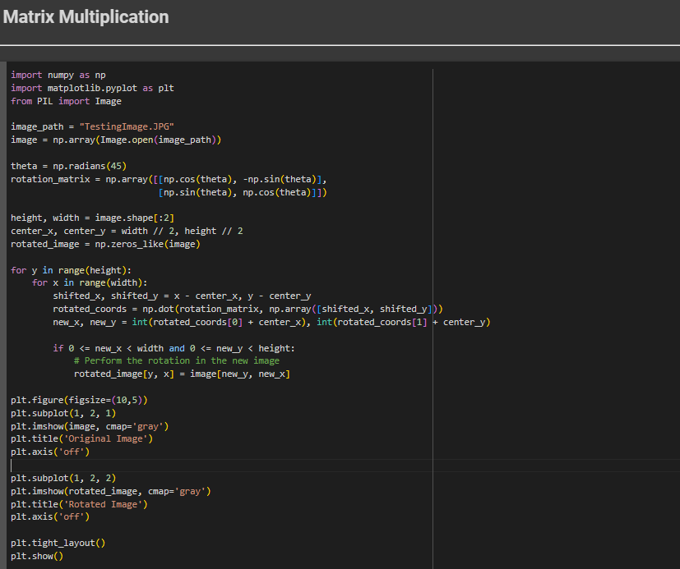

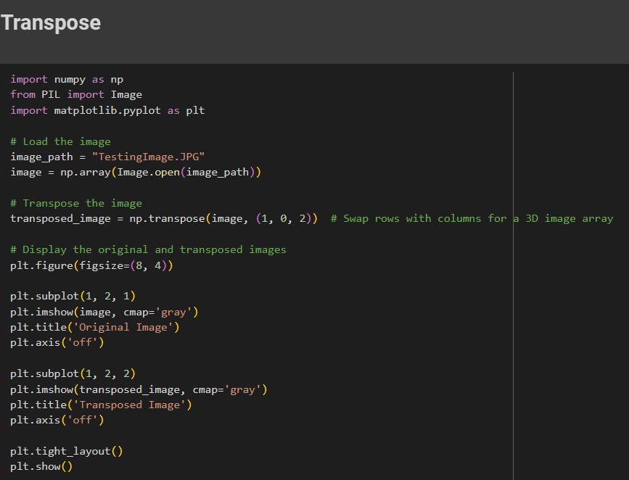

1. **References**
2. Ashraf, K., Salah, K., Ibrahim, M., Wail, O., Sallam, A. .(2023). Image Processing. [finaldraft_2023.docx](https://nileuniversity-my.sharepoint.com/:w:/r/personal/y_ashraf2113_nu_edu_eg/Documents/Desktop/finaldraft_2023.docx?d=wd7db23b98f0b475f98608ce52dda2cf3&csf=1&web=1&e=t1aRlB)
3. Shah, Atharva. (2023). Analysis of the usage of linear algebra in image processing. ResearchGate. <https://www.researchgate.net/publication/369589234_Analysis_of_the_usage_of_linear_algebra_in_image_processing>
4. Caridade, C. M. R., & da Nora, R. P. N. Q. (2011). Applying image processing techniques to motivate students in linear algebra classes. *learning*, *2*, 13.

<https://citeseerx.ist.psu.edu/document?repid=rep1&type=pdf&doi=528842781042a39ed28005201d70412a275baadc>

1. Dhanorkar, G., Nalawade, N., & Patil, P. (2023). LINEAR ALGEBRA AND IMAGE PROCESSING USING PYTHON. *The Online Journal of Distance Education and e-Learning*, *11*(2).

<https://tojdel.net/journals/tojdel/articles/v11i02b/v11i02b-81.pdf>

1. Sawant, L. S., & Patil, S. A. (2020). Cryptography and Image Processing by Matrices. International Research Journal of Engineering and Technology (IRJET), 07(08), 4327. [IRJET-V7I8746.pdf](https://www.irjet.net/archives/V7/i8/IRJET-V7I8746.pdf)
2. **Divided work**

|  |  |
| --- | --- |
| **Name** | **Tasks** |
| Youssef Ashraf ElNaggar | Abstract, Introduction (linear role, previous papers, aim of the study), resources, the document formatting, conclusion |
| Nada Ahmed Othman | Abstract, Introduction (linear role, previous papers, aim of the study), resources, citation of papers |
| Youssef Hatem Mostafa | Methodology and Results of Brightness Adjustment (Scalar Multiplication) |
| Abdelrahman Yasser Hussien | Methodology and Results of Image Rotation (Matrix Multiplication) |
| Youssef Mahmoud Abdelsamea | Methodology and Results of Manipulating Orientation (Transpose Operation) |
| Mostafa Mohamed Eleimy | Methodology and Results of Image inversion |